Who turns
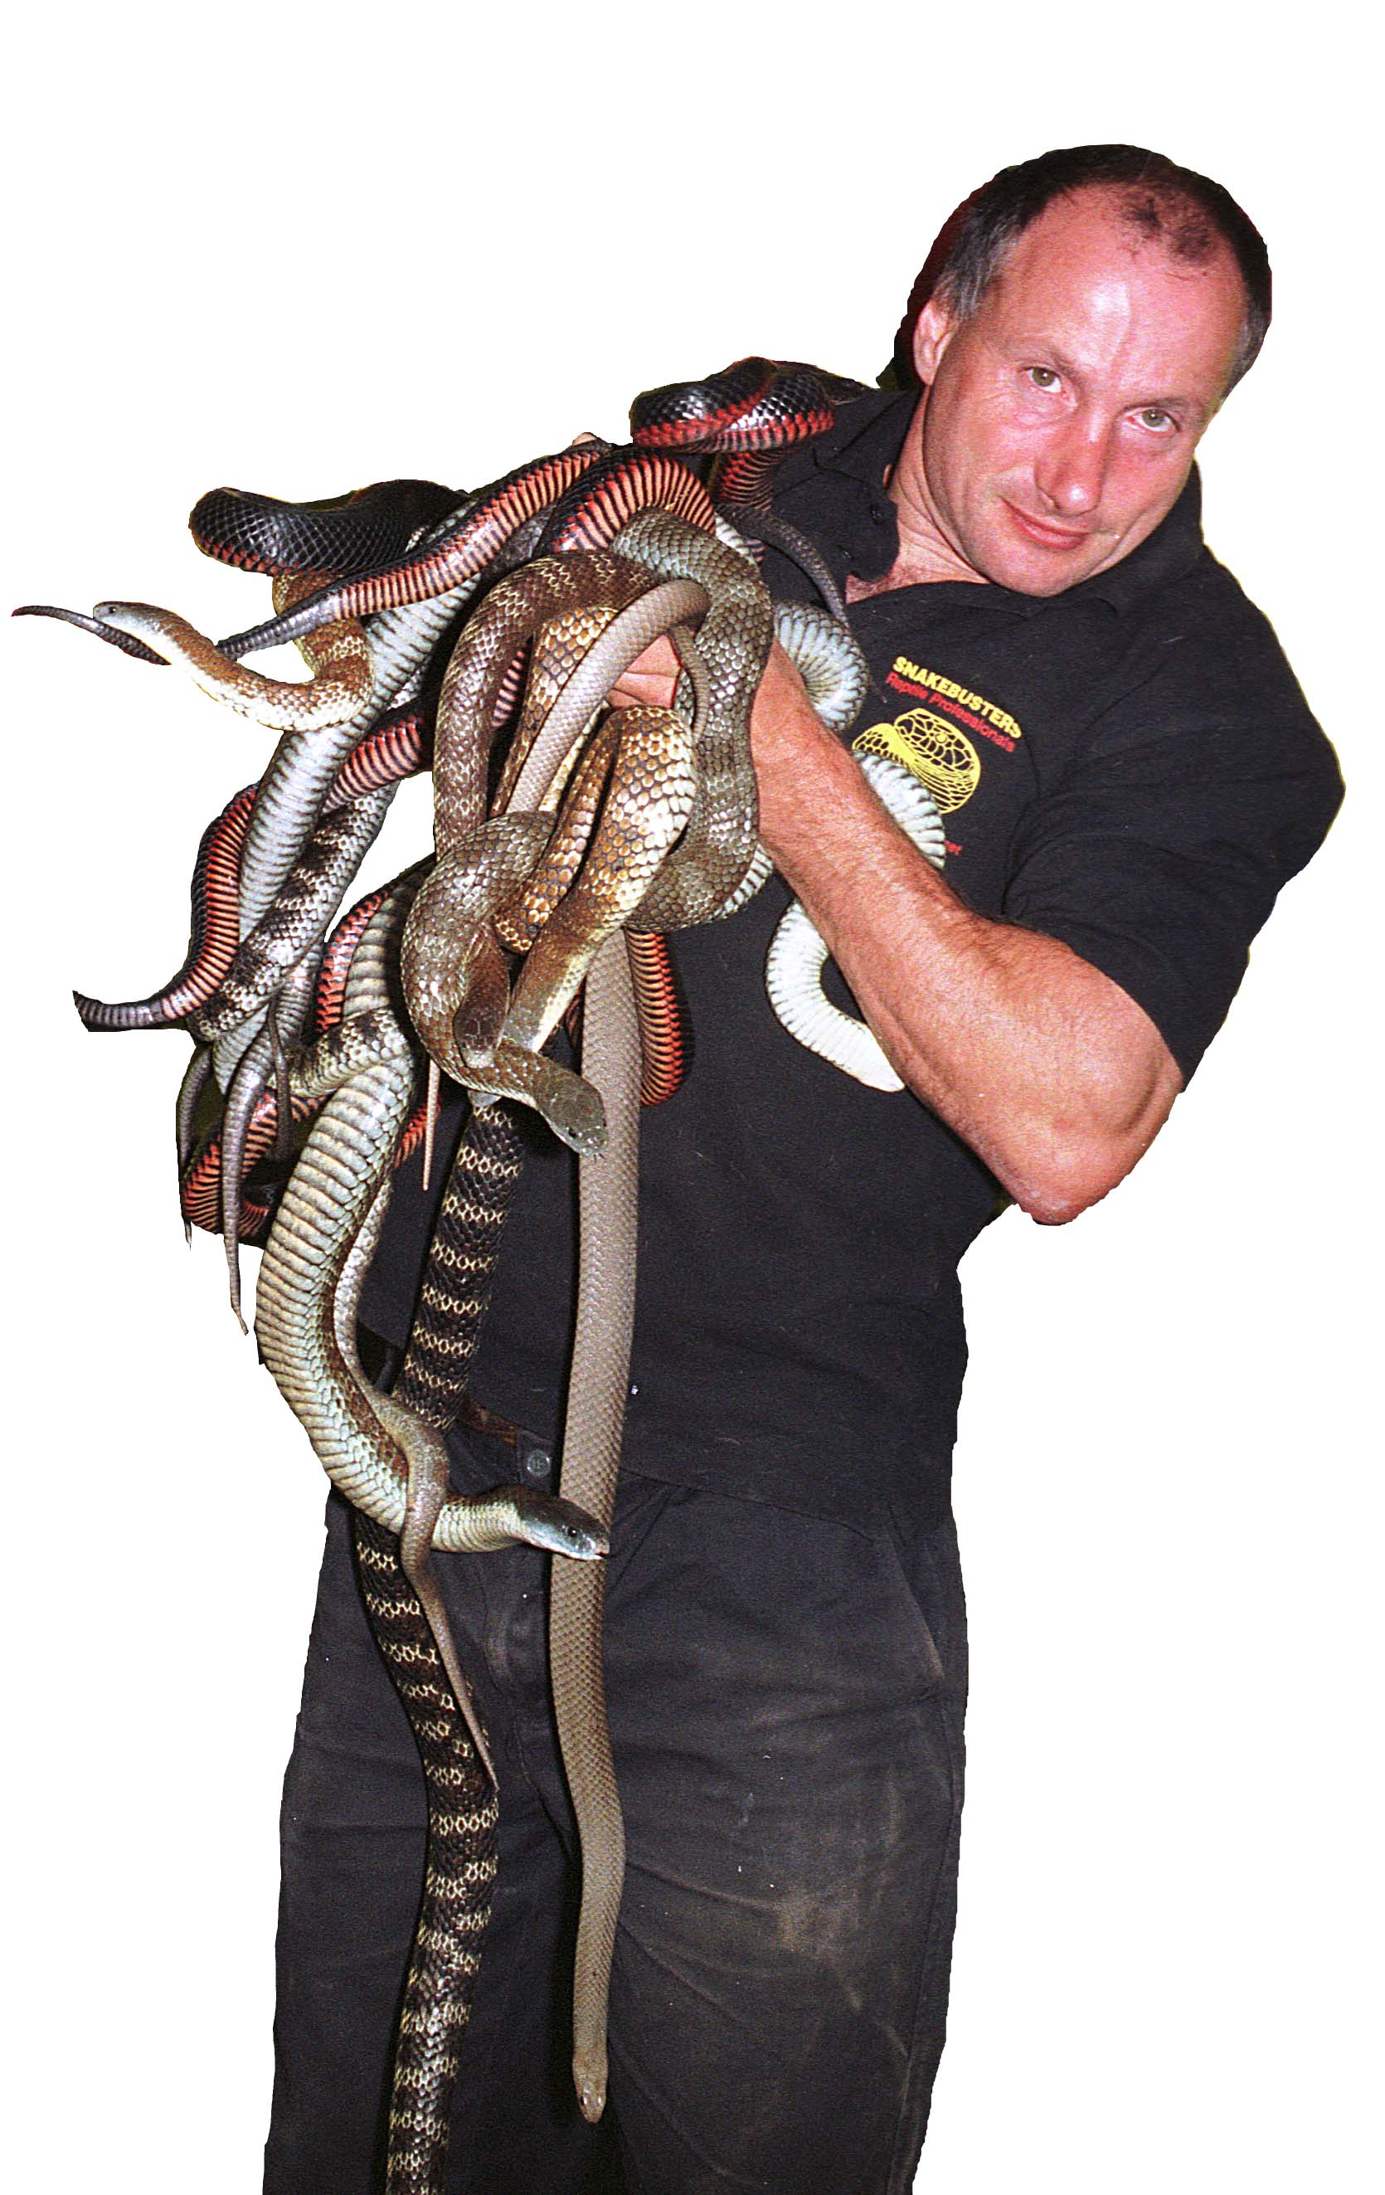
The party’s on

Starting at

Also coming along are Snakebusters Australia’s best reptiles
Our address is:

RSVP

